Where do I belong?
DATE: March 29/20
Key Verses:
Jeremiah 29:11
“For I know the plans I have for you,” declares the Lord, “plans to prosper you and not to harm you, plans to give you hope and a future.
James 1:22
Do not merely listen to the word, and so deceive yourselves. Do what it says.
Key Questions to Ask:
- What things can you be a part of?
- What are you good at?
- Can God use you?
- What is the most important thing you need to remember from all of the weeks we have gone through?
- Where can you look to find out where belong and what can you do?

Key Points:
- We have covered a lot over the last weeks but now you need to do the rest by praying and finding out where God wants you to be and what role he has for you

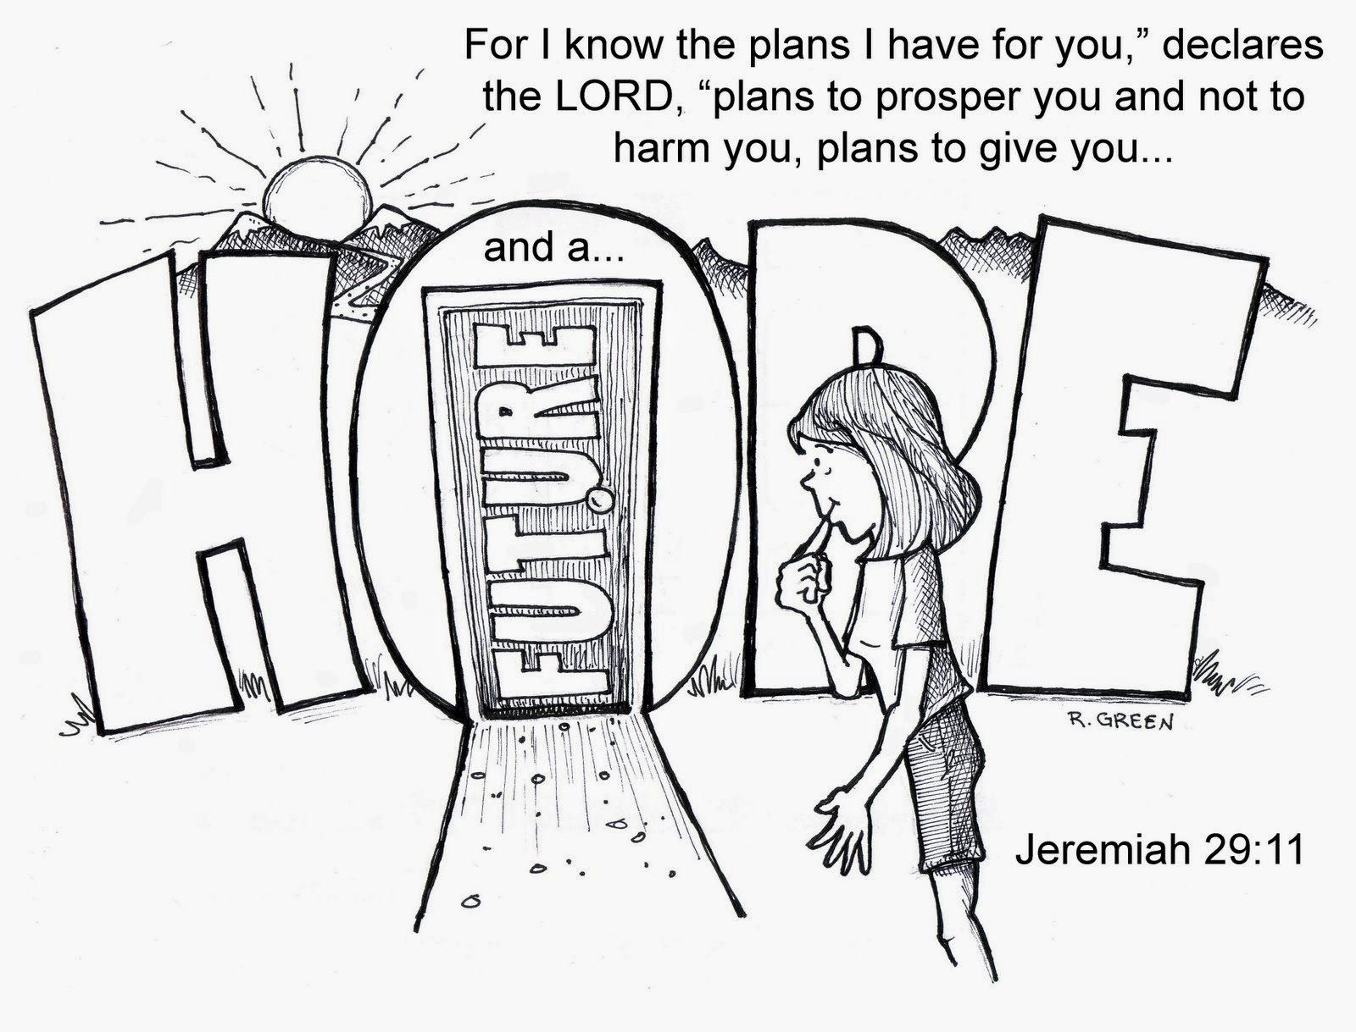

Parents, now is a good time to talk to your kids about what it means to you to be a Christian! Explain to them that it’s not always easy (we’ve talked a lot about this in Sunday school, how some things are really hard to do especially when it is something God wants) but God will always be with you!
In fact He knows exactly what it is that you are going to do and it is the most perfect thing! But you now have to find out what that is.
Give your kids some ideas of things they can get involved in, like helping clean up at the church, spreading God’s message of love to others, praying for others.
Just remember the most important thing, it all starts with lesson number one. Having a relationship with God!!

