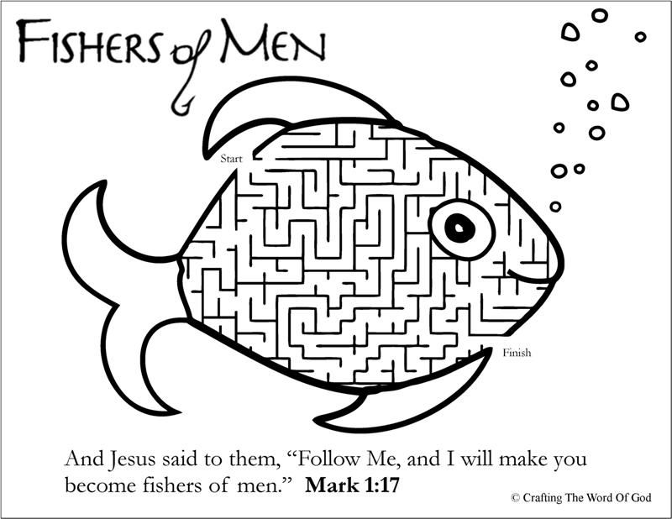
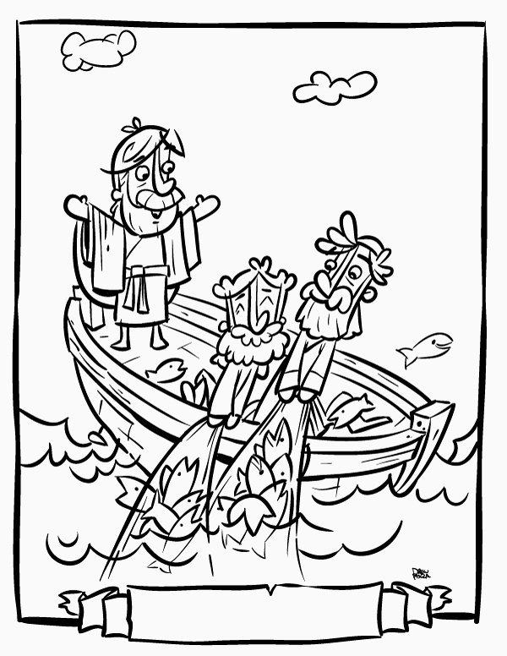
Ages 4 and up
Follow the Leader!

Key Verses:
Matthew 4:19-20
“Come, follow me,” Jesus said, “and I will send you out to fish for people.” At once they left their nets and followed him.

With everything going on right now it is even more important than ever to follow our leaders and it’s a great time to talk to our kids about following our leaders. You can use this time to teach your kids that God is the ultimate authority but He did give us people who are in charge of things and we need to listen to them as well. Whether this is doctors or policemen, teachers, pastors, brothers or sisters and their parents, they are all doing a job that they felt called to do.
We have a job to do as well and that is to spread God’s love and kindness, to share His message and to teach others about Him! Use the overview to ask your kids questions and engage with them. A fun game of follow the leader is a great way to show them that when a leader asks something we need to do it.
Pray with your kids and ask them to pray for our leaders and to help guide them through these different times

Key points to make with your kids:
• We need to follow God
• He gave us a job to do
• Just like with the disciple’s way back then we need to do what Jesus did
Questions to engage your kids with:
• What kinds of people do we follow?
• Who should we follow first?
• What things did Jesus do that we need to copy?
• Is it easy to follow the leader?

